绝密★启用前
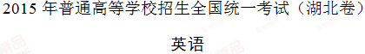
本试题卷共16页，81题。全卷满分150分。考试用时120分钟。
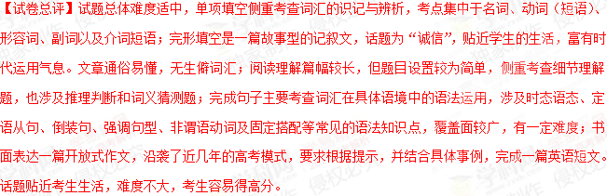★祝考试顺利★
注意事项：
1. 答卷前，先将自己的姓名、准考证号填写在试题卷和答题卡上，并将准考证号条形码粘贴在答题卡上的指定位置。用统一提供的2B铅笔将答题卡上试卷类型A后的方框涂黑。
2. 选择题的作答：每小题选出答案后，用统一提供的2B铅笔把答题卡上对应题目的答案标号涂黑。写在试题卷、草稿纸和答题卡上的非答题区域均无效。
3. 完成句子和短文写作题的作答：用统一提供的签字笔直接答在答题卡上对应的答题区域内。写在试题卷、草稿纸和答题卡上的非答题区域均无效。
4. 考试结束后，请将本试题卷和答题卡一并上交。
第一部分：听力（共两节，满分30分）（略）
第一节（共5小题；每小题1.5分，满分7.5分）
听下面5段对话。每段对话后有一个小题，从题中所给的A、B、C三个选项中选出最佳选项，并标在试卷的相应位置。听完每段对话后，你都有10秒钟的时间来回答有关小题和阅读下一小题。每段对话仅读一遍。
1. What does Tom plan to do next week?
A. To make a robot
B. To enter a competition.
C. To surprise the woman.

2. What is the woman?
A. A waitress.
B. A tour guide.
C. A saleswoman.

3. What is the woman’s problem?
A. She forgot her seat number.
B. She got on the wrong train.
C. She lost her train ticket.

4. Why has the man stopped exercising?
A. He is busy moving house.
B. He lives far away from the gym.
C. He dislikes going to the gym alone.

5. How is Janet probably feeling now?
A. Disappointed.
B. Confused.
C. Stressed.
第二节（共15小题；每小题1.5分，满分22.5分）
听下面5段对话或独白。每段对话或独白后有几个小题，从题中所给的A、B、C三个选项中选出最佳选项，并标在试卷的相应位置。听每段对话或独白前，你将有时间阅读各个小题，每小题5秒钟;听完后，各小题将给出5秒钟的作答时间。每段对话或独白读两遍。
听第6段材料，回答第6、7题。
6. How long is the woman going to stay at the hotel?
A. Two nights.
B. Three nights.
C. Four nights.

7. Why are the prices for the two rooms different?
A. The rooms are different in size.
B. The rooms have different views.
C. The rooms are of different shapes.

听第7段材料，回答第8、9题。
8. How did the man come to the place?
A. By car. B. On foot. C. By train.

9. Why is the man here?
A. To have an interview.
B. To discuss traffic problems.
C. To share his work experience.

听第8段材料，回答第10至12题。
10. Where are the speakers?
A. In a bank.
B. On a lake.
C. At a hotel.

11. Why does David’s father want to spend Christmas in the countryside?
A. He can enjoy the lake view.
B. He can be freed from housework.
C. He can have some peace and quiet.

12. Why is David unhappy?
A. He can’t attend the party.
B. He isn’t allowed to skate.
C. He has to cook for his parents.

听第9段材料，回答第13至16题。
13. How does Steven describe his music?
A. It’s hard rock.
B. It’s folk music.
C. It’s modern pop.

14. Why does Steven love Australian audiences?
A. They never throw things at him.
B. They buy more of his records.
C. They are more friendly.

15. What’s Steven’s attitude towards people downloading his music?
A. He doesn’t mind.
B. He feels upset.
C. He is puzzled.

16. What advice does Steven give to songwriters?
A. Listen to more music.
B. Stick to their own style.
C. Make use of the Internet.

听第10段材料，回答第17至20题。
17. Which can best describe a tension headache?
A. It occurs repeatedly.
B. It lasts over a month.
C. It causes severe pain.

18. Which is a symptom of tension headaches?
A. Loss of consciousness.
B. Increased blood pressure.
C. A pain at the back of the head.

19. What is the cause of rebound headaches?
A. Stressful events.
B. Tension in the muscles.
C. Too much use of pain medicine.

20. Why is a headache diary helpful for the treatment?
A. It helps one find the cause of his headaches.
B. It reminds one to take medicine on time.
C. It helps remove constant pain.
答案
第一部分：听力（每小题1.5分，满分30分）
1. B 2. A 3. B 4. C 5. C
6. B 7. B 8. A 9. A 10. C
11. C 12. A 13. A 14. C 15. A
16. B 17. A 18. C 19. C 20. A

听力原文
Text 1
W: What a cool robot! Did you make it, Tom?
M: Yes. I’m glad you like it. It’s for the competition next week.
W: I won’t be surprised if you win the first prize.
Text 2
W: Do you like fried chicken? Ours is the best in the country.
M: I’m not sure. I guess I need another minute.
W: OK. Take your time. You’ve got all the local dishes on the menu.
Text 3
M: Excuse me, but I think this seat — 16C — is mine.
W: That’s strange. Mine is 16C, too. Here is my ticket.
M: Sorry, ma’am. Your train is G90. This is G96.
Text 4
W: Hey, Jack. You really need to start to exercise.
M: Yes, I know. I’m putting on weight.
W: Why did you quit gym anyway?
M: Well, my roommate has moved out, and I really hate to go to the gym alone.
Text 5
M: How’s your day going, Janet?
W: Quite busy. I’m preparing a research report. The deadline is tomorrow. But I haven’t finished even half of it.
M: Poor girl!
Text 6
M: Hello, Victoria Hotel. Can I help you?
W: Hello. I’d like to make a reservation for July the 1st through the 4th. I’m…I’m checking out on the morning of the 4th.
M: OK, single room or double room?
W: I’d like a double room. What’s the rate?
M: We have only two double rooms available. One is $180 and the other $200.
W: Why are the prices different?
M: Well, they are both standard double rooms, but the $200 room faces the garden.
W: OK, I see.
Text 7
W: Hi, I’m Jane. Pleased to meet you!
M: Hi, Jane. I’m glad to be here for the interview.
W: Did you have problems finding this place?
M: Not at all. But the traffic was not easy. And it took me hours to find a parking space.
W: Traffic has always been difficult these days.
M: It would have been so much easier if a train or a subway line went through here.
W: Yes, you’re definitely right. Well, why don’t we start by telling me about your previous work experience?(https://www.171english.cn)
Text 8
W: Look out of the window, David. There is ice on the lake. Actually, there is ice all over the lake.
M: Yeah.
W: And there are many people skating over there. Do you want to join them?
M: I’m not in the mood. When are we going back to the city?
W: Not until January the 3rd. It’s your dad’s idea to spend Christmas at this country hotel.
M: I want to stay in New York. Barbara has asked me to a party on New Year’s Eve.
W: Your dad works very hard at the bank. He needs a quiet Christmas. It will be nice for me, too. I won’t have to cook.
M: Oh, this is going to be the most boring Christmas that I’ve ever had!
W: Take it easy, boy!
Text 9
W: Good evening, Steven. Thank you for being with us.
M: Thank you for having me.
W: So Steven, as a guitar player, how would you describe your music? Is it a kind of folk rock, or a mixture of pop and rock?
M: Well, I just want it to be real rock, hard and solid.
W: Has it changed since your first record?
M: No. I’m happy with what I can do.
W: Where are your favorite places to play?
M: Oh, I love Australia. People here are all smiles.
W: So no one throws things onto the stage in Australia?
M: People throw things everywhere. You can’t stop that.
W: What do you think of the people who download your music from the Internet?
M: Well, the truth is people who download your music are people who are interested in your music. And if you’re upset about that, then what’s the point?
W: Thanks, Steven. Before we finish, can you offer any tips on becoming a better songwriter?
M: Stop listening to other people’s songs. Be yourself.
Text 10
Good evening. This is Dr. Kay. In our program today, we’ll talk about tension headaches. Most headaches are tension headaches. These headaches tend to happen again and again, especially if you’re under stress. They’re not usually a sign of something serious, but they can last from 30 minutes to 7 days. Things such as stress, hunger, and even a change of weather can lead to a tension headache. Symptoms of it include a headache that is constant but not severe, and a pain at the back of your head and the neck. If you have a tension headache, you may also feel the pressure on both sides of your head. Most people treat their tension headaches with pain medicine. But be cautious. If you take the medicine more than three times a week, you may get a rebound headache, which is far more severe than tension headaches. Rebound headaches start whenever you stop taking the medicine. Home treatment may help you avoid tension headaches. Try to reduce stress. More importantly, try using a headache diary. Each time you get a headache, write down the date, the time, and what you were doing and feeling before your headache started. This may help you and your doctor find out the cause and then plan your treatment. That’s all for today’s program. Thank you

第二部分：词汇知识运用（共两节，满分30分）
第一节：多项选择（共10小题；每小题1分，满分10分）
从A、B、C、D四个选项中，选出可以填入空白处的最佳选项，并在答题卡上将该项涂黑。学科网
例：To make members of a team perform better, the trainer first of all has to know
their _____ and weaknesses．
A. strengths B. benefits C. techniques D. values
答案：A

21.When he was running after his brother, the boy lost his ___ and had a bad fall.
A.balance B .chance C .memory D .place
【答案】A
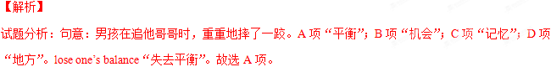【考点定位】名词词义辨析
【名师点睛】本题侧重考查在特定的语境中辨析名词词义的能力。四个选项都可以跟前面的动词lose搭配。考生应抓住题干中关键信息“had a bad fall（重重地摔了一跤）”，不禁会产生疑问：怎么会摔了一跤呢？然后根据搭配lose one’s balance“失去平衡”锁定正确答案。
22.He gave himself a new name to hide his ____ when he went to carry out the secret task.
A.emotion B.talent C.identity D.treasure
【答案】C
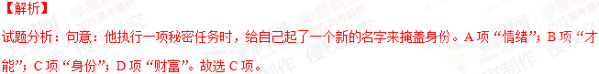【考点定位】名词词义辨析
【名师点睛】考生解答本题的关键是抓住题干中的关键词“secret task（秘密任务）”和“ gave himself a new name（给自己取了个新名字）”，然后推知肯定是为了“hide his identity（掩藏身份）”，从而锁定正确答案。
23.The team are working hard to ___ the problem so that they can find the best solution.
A.face B.prevent C.raise D.analyze
【答案】D
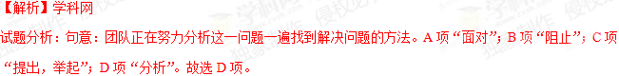【考点定位】动词词义辨析
【名师点睛】四个选项都可以与problem构成搭配，但只有一个符合句意。考生一定要结合语境，抓住句中的关键词，“find the best solution（找到最佳解决办法）”，“so that”这里引导的是目的状语从句，据此判断前面应为分析问题“analyze the problem”。考生应注意：切不可只根据搭配，这样可能会做出错误的选择。
24.In order not to be heard, she pointed her finger upwards to ____ that someone was moving about upstairs.
A.whisper B.signal C.declare D.complain
【答案】B
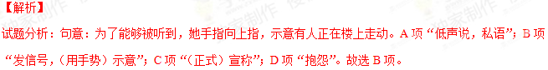
【考点定位】动词词义辨析
【名师点睛】此题有一定难度，涉及到“熟词新义”。signal基本义是“发信号”，而“示意，暗示”这一“新义”需要靠考生平时积累。当然，还可以运用关键词法，“pointed her finger upwards（她用手向上指）”，据此可以推知这一动作就是在“示意，暗示”。
25.There is no doubt that this candidate’s advantage _____ his ability to communicate with foreigners in English.
A.leaves out B.goes against C.lies in D.makes up
【答案】C
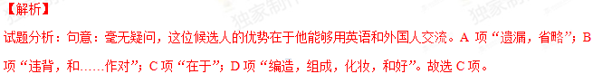【考点定位】动词短语辨析
【名师点睛】考生要注意这里的he和candidate指的是同一个人，弄清这一点，再分析他的优势与他用英语跟外国人交流的能力之间的关系，很容易判断出“优势在于……”这层关系。另外考生注意积累There is no doubt that“毫无疑问”这一常考结构。
26.Don’t worry. I’m sure your missing glasses will ______ sooner or later.
A.stand out B.break up C.get out D.turn up
【答案】D
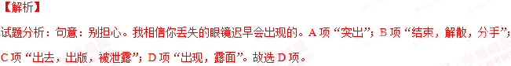【考点定位】动词短语辨析
【名师点睛】本题语境贴近学生生活，生活中我们都有过这样的经历，找不到的东西过段时间又自己冒出来，考生可以利用这一语境并联系日常生活作答该题。另外，还可以抓住题干中的关键词“Don’t worry”和“sooner or later”迅速锁定正确答案。
27.Even though the conference hall is near his apartment, he has to hurry a little if he wants to be_____.[来源:学科网]
A.accurate B.punctual C.efficient D.reasonable
【答案】B
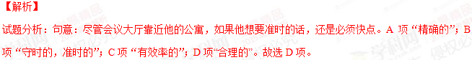【考点定位】形容词词义辨析
【名师点睛】本题侧重考查在特定的语境中辨析形容词词义的能力。因此，考生必须充分利用这一特定语境。根据题干中的关键词“hurry a little”可推知他想要准时（守时）。考生容易误选C项efficient“有效率的”，侧重指积极有效，效率高，效果好，节省精力。指人时，强调其能干、熟练的技巧。
28.I don’t think what he said is _____ to the topic we are discussing . He has missed the point.
A.faithful B.parallel C.relevant D.similar
【答案】C
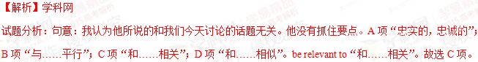【考点定位】形容词词义辨析
【名师点睛】本题侧重考查在特定的语境中辨析形容词词义的能力。四个选项都有“be+adj.+to”的用法，但意义相差较大。根据题干中的关键词“missed the point（跑题，没抓住要点）”可推知他所说的和话题无关。
29.The girl used to be shy, but is ____ getting active in group work and is more willing to express herself.
A.gradually B.usually C.previously D.merely
【答案】A
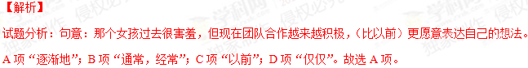【考点定位】副词词义辨析
【名师点睛】本题侧重考查在特定的语境中辨析副词词义的能力。考生可根据“人的性格改变是需要一个过程的”这一常识迅速锁定正确选项，也可以根据题干中的关键词“used to be shy”和“and is more willing to express herself”这两个时态推知她的性格在逐渐改变。考生要注意used to的言外之意，意为“过去常常”, 暗指现在已经不存在的动作或状态,强调“今昔之比”。
30.This meeting room is a non-smoking area. I would like to warn you _____ that if you smoked here you would be fined.
A.in advance B.in detail C. in total D.in general
【答案】A
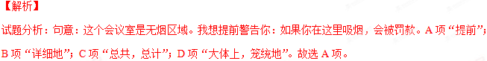【考点定位】介词短语辨析
【名师点睛】本题侧重考查在特定的语境中辨析介词短语的能力。题干中的关键词“if you smoked here you would be fined”这一虚拟语气表示这是假设的情况，因此是在“提前”警告某人。另外，考生应注意积累“in+n.(+of)”这一常考搭配。
第二节：完形填空（共20小题；每小题1分，满分20分）
阅读下面短文，从短文后各题所给的四个选项（A、B、C和D）中，选出可以填入空白处的最佳选项，并在答题卡上将该项涂黑。
“Daily Star, sir” called Jason, carrying some newspapers under his arm. The little boy had been running up and down the street, but there were still twenty_31__left. His voice was almost gone and his heart was_32__. The shops would soon close, and all the people would go home. He would have to go home too, carrying the papers__33_money. He had hoped to sell more papers tonight to make more money to buy a__34_for his mother and some seeds for his bird. That was why he had bought the papers with all his money. He_35__as he thought of his failure to sell all his papers.
“You don’t know the __36_of selling papers. You must shout, “Hot news! Bomb bursting!” another newsboy Chad told Jason. “_37__it’s not in the paper at all,” replied Jason. “Just run away quickly__38__they have time to see, and you’ll__39_out and get your money,”Chad said.[来源:学。科。网Z。X。X。K]
It was a new _40__to Jason. He thought of his bird with no__41_and the cake he wanted to buy for his mother, but was__42_that he would not tell a lie. Though he was _43__ a poor newsboy, he had been_44__ some good things.
The next afternoon Jason went to the office for his papers_45__. Several boys were crowding around Chad, who declared with a__46_smile that he sold six dozen the day before. He added that Jason__47_money because he would not tell a lie. The boy _48__at Jason. “You wouldn’t tell a lie yesterday, my boy?” A gentleman at the office came up and patted Jason’s shoulder__49_.”You’re just the boy I am looking for.” A week later Jason started his new__50_. He lost sale of twenty papers because he would not tell a lie, but got a well-paid job because he told the truth.
31.A.shops B.coins C.people D.papers
32.A.open B.heavy C.pure D.weak
33.A.instead of B.in return for C.regardless of D.in exchange for
34.A.cup B.card C.comb D.cake
35.A.gave in B.broke down C.got away D.showed up
36.A.difficulty B.process C.goal D.secret
37.A.And B.But C.For D.So
38.A.before B.since C.though D.unless
39.A.call B.drop C.sell D.reach
40.A.edition B.idea C.policy D.task
41.A.bread B.insects C.seeds D.water
42.A.concerned B.amazed C.excited D.determined
43.A.still B.already C.just D.also
44.A.taught B.handed C.awarded D.allowed
45.A.at once B.by chance C.as usual D.on purpose
46.A.proud B.gentle C.warm D.polite
47.A.borrowed B.lost C.made D.saved
48.A.laughed B.shouted C.nodded D.started
49.A.bravely B.grateful C.fondly D.modestly
50.A.duty B.business C.job D.method
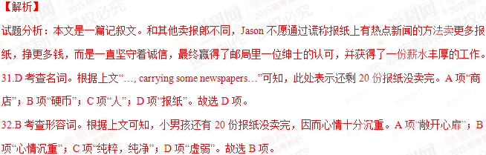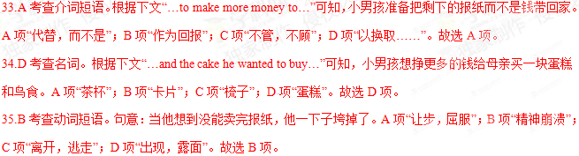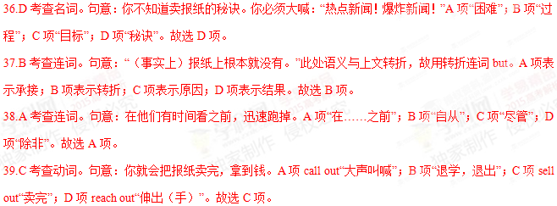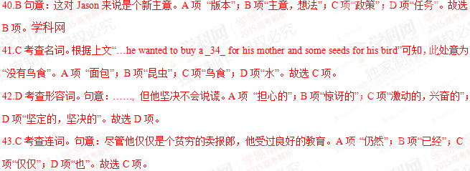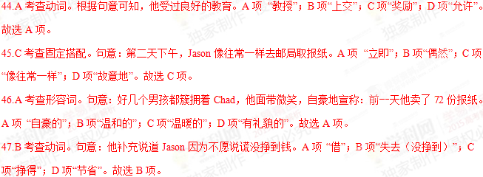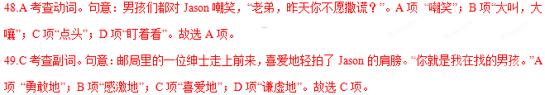
【考点定位】记叙文阅读。
【名师点睛】今年湖北高考英语完形填空总体难度有所下降，无生僻单词和复杂句子，考生容易读懂，但个别题目比较纠结,如33、35短语辨析。文章讲述的是一个小报童因诚实亏钱，后又因诚实获得好工作的跌宕起伏的故事。全文凸显人文气息，彰显树人价值导向。考生只要依据故事情节发展，结合上下文复现信息，就可以正确作答。
第三部分：阅读理解（共20小题；每小题2分，满分40分）
阅读下列短文，从每篇短文后各题所给的四个选项（A、B、C和D）中，选出最佳选项，并在答题卡上将该项涂黑。
A
“I see you’ve got a bit of water on your coat,” said the man at the petrol station. “Is it raining out there?”“No, it’s pretty nice,” I replied, checking my sleeve. “Oh, right. A pony(马驹) bit me earlier.”
As it happened, the bite was virtually painless: more the kind of small bite you might get from a naughty child. The pony responsible was queuing up for some ice cream in the car park near Haytor, and perhaps thought I’d jumped in ahead of him.
The reason why the ponies here are naughty is that Haytor is a tourist-heavy area and tourists are constantly feeding the ponies foods, despite sighs asking them not to. By feeding the ponies, tourists increase the risk of them getting hit by a car, and make them harder to gather during the area’s annual pony drift(迁移).
The purpose of a pony drift is to gather them up so their health can be checked, the baby ones can be stooped from feeding on their mother’s milk, and those who’ve gone beyond their limited area can be returned to their correct area. Some of them are also later sold, in order to limit the number of ponies according to the rules set by Natural England.
Three weeks ago, I witnessed a small near-disaster a few mils west of here. While walking, I noticed a pony roll over on his back. “Hello!” I said to him, assuming he was just rolling for fun, but he was very still and, as I got closer, I saw him kicking his legs in the air and breathing heavily. I began to properly worry about him. Fortunately, I managed to get in touch with a Dartmoor’s Livestock Protection officer and send her a photo. The officer immediately sent a local farmer out to check on the pony. The pony had actually been trapped between two rocks. The farmer freed him, and he began to run happily around again.
Dartmoor has 1,000 or so ponies, who play a critical role in creating the diversity of species in this area. Many people are working hard to preserve these ponies, and trying to come up with plans to find a sustainable(可持续的) future for one of Dartmoor’s most financially-troubled elements.
51.Why are tourists asked not to feed the ponies?
A. To protect the tourists from being bitten
B. To keep the ponies off the petrol station
C. To avoid putting the ponies in danger
D. To prevent the ponies from fighting[来源:Z.xx.k.Com]
52.One of the purposes of the annual pony drift is ______________.
A. to feed baby ponies on milk
B. to control the number of ponies
C. to expand the habitat for ponies
D. to sell the ponies at a good price
53.What as the author’s first reaction when he saw a pony roll on its back?
A. He freed it from the trap
B. He called a protection officer
C. He worried about it very much
D. He thought of it as being naughty
54.What does the author imply about the preservation of Dartmoor’s ponies?
A. It lacks people’s involvement.
B. It costs a large amount of money
C. It will affect tourism in Dartmoor.
D. It has caused an imbalance of species
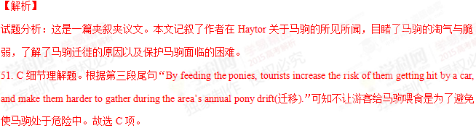
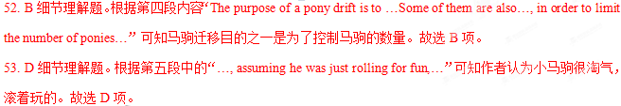
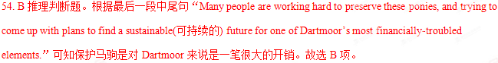
【考点定位】夹叙夹议文阅读
【名师点睛】夹叙夹议文是近几年高考经常涉及的一类文体，文章一方面叙述事情，另一方面又对事情加以评论，此类文章一般先提出论点，然后以事例说明论点，最后得出结论，或者一边叙述事情经过，一边对事情加以分析评论，文章最后一段用一句概括性的话点明主题，将叙述和议论有机地结合起来，其中“叙”是“议”的基础，“议”是“叙”的渗透和延伸。考生要注意在通读全文的基础上弄清文章结构，阅读时重点要放在议论部分，因为该部分表达了作者的观点或看法，是文章的精髓。理解了作者的观点和看法，也就把握了全文的主要内容。本文难度不大，通过作者与小马的“亲密接触”介绍了英国达特穆尔荒原淘气的矮种马，散发出浓浓的英伦风。
B

What Theresa Loe is doing proves that a large farm isn’t prerequisite for a modern grow-your-own lifestyle. On a mere 1/10 of an acre in Los Angeles, Loe and her family grow, can（装罐）and preserve much of the food they consume.

Loe is a master food preserver, gardener and canning expert. She also operates a website, where she shares her tips and recipes, with the goal of demonstrating that every has the ability to control what’s on their plate.

Loe initially went to school to become an engineer, but she quickly learned that her enthusiasm was mainly about growing and preparing her own food. “I got into cooking my own food and started growing my own herbs (香草) and foods for that fresh flavor,”she said. Engineer by day, Loe learned cooking at night school. She ultimately purchased a small piece of land with her husband and began growing their own foods.

“I teach people how to live farm-fresh without a farm,” Loe said. Through her website Loe emphasizes that “anybody can do this anywhere.” Got an apartment with a balcony （阳台）? Plant some herbs. A window? Perfect spot for growing. Start with herbs, she recommends, because “they’re very forgiving.” Just a little of the herbs “can take your regular cooking to a whole new level,” she added. “I think it’s a great place to start.” “Then? Try growing something from a seed, she said, like a tomato or some tea.”

Canning is a natural extension of the planting she does. With every planted food. Loe noted, there’s a moment when it’s bursting with its absolute peak flavor. “I try and keep it in a time capsule in a canning jar,” Loe said. “Canning for me is about knowing what’s in your food, knowing where it comes from.”

In addition to being more in touch with the food she’s eating, another joy comes from passing this knowledge and this desire for good food to her children: “Influencing them and telling them your opinion on not only being careful what we eat but understanding the bigger picture,” she said, “that if we don’t take care of the earth, no will.”
55.The underlined word “prerequisite” (Pare. 1) is closest in meaning to “______”.
A. recipe B. substitute C. requirement D. challenge
56.Why does Loe suggest starting with herbs?
A. They are used daily.
B. They are easy to grow.
C. They can grow very tall
D. They can be eaten uncooked
57.According to Loe, what is the benefit of canning her planted foods?
A. It can preserve their best flavor
B. It can promote her online sales
C. It can better her cooking skills
D. It can improve their nutrition
58.What is the“the bigger picture” (Para. 6) that Loe wishes her children to understand?
A. The knowledge about good food
B. The way to live a grow-our-own life
C. The joy of getting in touch with foods
D. The responsibility to protect our earth
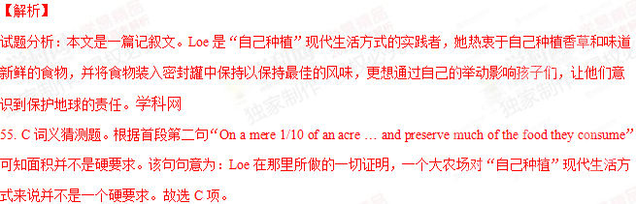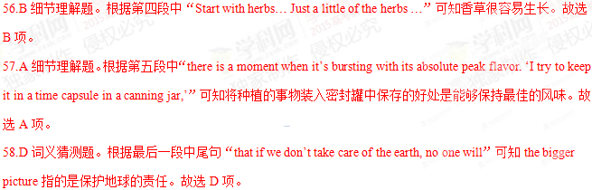【考点定位】记叙文阅读
【名师点睛】记叙文体裁特点是：人不离事,事不离人。写人的文章事情是重点；记事的文章人物是关键。考生要注意抓住故事情节，理解文章脉络，重点关注作者重墨泼就的细节描写，领会作者的写作意图。同时还要把握人物的情绪起伏,要进入“角色”，客观做题。本文顺应当前社会生活潮流，介绍了园艺和食品保存大师Theresa Loe如何利用阳台、小院在喧嚣繁忙的大都市里过田园生活。
C
Hilversum is a medium-sized city between the major cities of Amsterdam and Utrecht in the Gooi area of North Holland, the Netherlands. Unlike most of the Netherlands, Hilversum is actually in a hilly area with the soil mostly consisting of sand. Once called the Garden of Amsterdam, it still attracts travelers to come over to cycle and walk through the surrounding forests. They visit it for a relaxing day off from the urban madness. For Dutch people, Hilversum is all about textile (纺织) and media industries, and modern architecture.
In history, Hilversum was largely an agricultural area. Daily life was marked by farming, sheep raising and wool production. A railway link to Amsterdam in 1874 attracted rich traders from Amsterdam to Hilversum. They build themselves large villas (别墅) in the wooded surroundings of the town. One of the families moving in was the Brenninkmeijers, currently the wealthiest family of the Netherlands. They moved in after big success in the textile industry and aided a substantial textile industry in Hilversum. But the textile boom lasted only several decades. The last factory closed in the 1960s.
The change to a media economy started in 1920, when the Nederlandse Seintoestedllen Fabriek (NSF) established a radio factory in Hiversum. Most radio stations called in the large villas in the leafy areas of the town. Television gave another push to the local economy. Hilversum became the media capital of the Netherlands, and Dutch televison stars moved into the leafy neighborhoods surrounding the town.
In the early 1900s, modern architcts W.M. Dudok and J. Duiker placed hundreds of remarkable buildings in Hilversum. These modern architectural masterpieces (杰作) are so many that Hilversum almost feels like an open air museum. Dudok alone shaped most 20th century Hilversum and approximately 75 buildings in 1928-1931. It has wide international fame and is included in many architecture textbooks. The building has a remarkable shape and looks like a combination of “blocks”. Actually, one may start his journey of modern architecture by walking or biking the W.M. Dudok Architectural Route in Hilversum.
59.Hilversum is different from most of the Netherlands in that ______.
A. it has a large population
B. it is cut off from big cities
C. it has many beautiful gardens
D. it is in a hilly area with sandy soil
60.What was the greatest contribution of the Brenninkmeijers to Hilversum?
A. Building a railway link to Amsterdam
B. Helping its textile industry to develop
C. Constructing large villas for the poor
D. Assisting its agricultural industry
61.The beginning of the media industry in Hilversum was marked by the establishment of ______.
A. a radio factory
B. the medial capital
C. a radio station
D. a TV station
62.What is known about W.M. Dudok’s Hilversum Town Hall?
A. It consists of approximately 75 buildings
B. It looks like an open air museum in the city
C. It is a classic example in architecture textbooks
D. It has shaped most of 20th century Hilvesum.
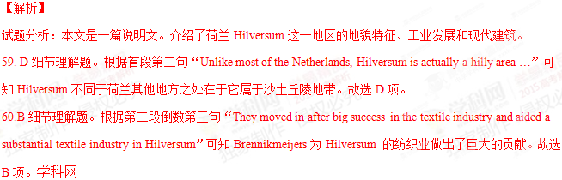
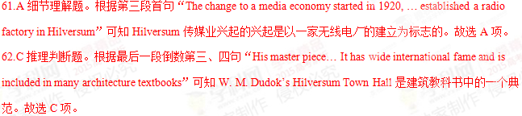【考点定位】说明文阅读
【名师点睛】说明文用平实的语言客观地解释或探讨各种问题，如机器的制造过程、自然或社会现象产生的原因、工程项目的规划或问题的解决方案等，介绍自然科学、社会科学领域的最新成果，社会经济发展过程中出现的新生事物等。本文虽短短几段，却囊括了荷兰小镇Hilversum的前世今生，把一个不怎么出名的小城栩栩如生地呈现在中国读者的眼前。
D
The oddness of life in space never quite goes away. Here are some examples.
First consider something as simple as sleep. Its position presents its own challenges. The main question is whether you want your arms inside or outside the sleeping bag. If you leave your arms out, they float free in zero gravity, often giving a sleeping astronaut the look of a funny balled （芭蕾）dancer. “I’m an inside guy,” Mike Hopkins says, who returned from a six-month tour on the International Space Station. “I like to be wrapped up.”
On the station, the ordinary becomes strange. The exercise bike for the American astronauts has no handlebars. It also has no seat. With no gravity, it’s just as easy to pedal violently. You can watch a movie while you pedal by floating a microcomputer anywhere you want. But station residents have to be careful about staying in one place too long. Without gravity to help circulate air, the carbon dioxide you exhale (呼气) has a tendency to form an invisible （隐形的）cloud around you head. You can end up with what astronauts call a carbon-dioxide headache.
Leroy Chiao, 54, an American retired astronaut after four flights, describes what happens even before you float out of your seat,”Your inner ear thinks your’re falling . Meanwhile your eyes are telling you you’re standing straight. That can be annoying—that’s why some people feel sick.” Within a couple days —truly terrible days for some —astronauts’ brains learn to ignore the panicky signals from the inner ear, and space sickness disappears.
Space travel can be so delightful but at the same time invisibly dangerous. For instance, astronauts lose bone mass. That’s why exercise is considered so vital that National Aeronautics and Space Administration (NASA) puts it right on the workday schedule. The focus on fitness is as much about science and the future as it is about keeping any individual astronauts return home, and, more importantly, how to maintain strength and fitness for the two and a half years or more that it would take to make a round-trip to Mars.
63.What is the major challenge to astronauts when they sleep in space?
A. Deciding on a proper sleep position
B. Choosing a comfortable sleeping bag
C. Seeking a way to fall asleep quickly
D. Finding a right time to go to sleep.
64.The astronauts will suffer from a carbon-dioxide headache when _____.
A. the y circle around on their bikes
B. they use microcomputers without a stop
C. they exercise in one place for a long time
D. they watch a movie while pedaling
65.Some astronauts feel sick on the station during the first few days because _____.
A. their senses stop working
B. they have to stand up straight
C. they float out of their seats unexpectedly
D. whether they are able to go back to the station
66.One of the NASA’s major concerns about astronauts is _____.
A. how much exercise they do on the station
B. how they can remain healthy for long in space
C. whether they can recover after returning home
D. whether they are able to go back to the station
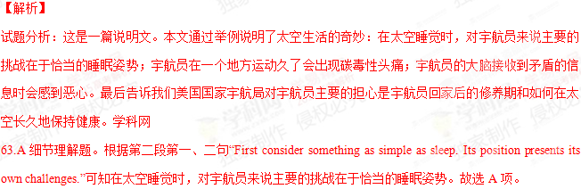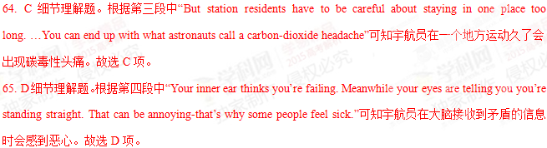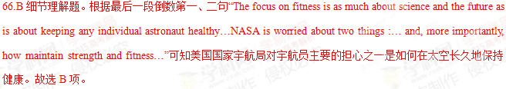
【考点定位】说明文阅读
【名师点睛】科普类说明文历来是高考阅读理解命题的重点，文章逻辑性强，条理清楚，主要考查学生对语篇的整体把握和领悟能力以及对特定细节的认读和处理能力。考生应注意：1.平时多读科普知识类文章，学习科普知识，积累常见的科普词汇，从根本上提高科普英语的阅读能力。2.熟悉科普类文章的结构特点。科普类文章一般由标题（高考题中一般不给出标题）、导语、背景、主体和结尾五部分构成。导语一般位于整篇文章的首段。背景交待一个事实的起因。主体则对导语概括的事实进行详细叙述，这部分是命题的重点，考生应该重点把握。结尾往往也是中心思想的概括，并与导语相呼应，命题者常在此要设计一道推理判断题。3. 在进行推理判断时，考生一定要以阅读材料所提供的科学事实为依据，同时所得出的结论还应符合基本的科普常识。
E
Science has a lot of uses. It can uncover laws of nature, cure diseases, make bombs, and help bridges to stand up. Indeed science is so good at what it does that there’s always a temptation(诱惑) to drag it into problems where it may not be helpful. David Brooks, author of The Social Animal: The Hidden Sources of Love, Character,and Achievement, appears to be the latest in a long line of writers who have failed to resist the temptation.
Brooks gained fame for several books. His latest book The Social Animal, however, is more ambitious and serious than his earlier books. It is an attempt to deal with a set of weighty topics. The book focuses on big questions: What has science revealed about human nature? What are the sources of character? And why are some people happy and successful while others aren’t?
To answer these questions, Brooks surveys a wide range of disciplines（学科）. Considering this, you might expect the book to be a dry recitation of facts. But Brooks has structured his book in an unorthodox(非常规的), and perhaps unfortunate, way. Instead of introducing scientific theories, he tells a story, within which he tries to make his points, perhaps in order to keep the reader’s attention.So as Harold and Erica, the hero and heroine in his story, live through childhood, we hear about the science of child development and as they begin to date we hear about the theory of sexual attraction. Brooks carries this through to the death of one of his characters.
On the whole,Brooks’ story is acceptable if uninspired. As one would expect, his writing is mostly clear and, to be fair, some chapters stand out above the rest. I enjoyed, for instance, the chapter in which Harold discovers how to think on his own. While Harold and Erica are certainly not strong or memorable characters, the more serious problems with The Social Animal lie elsewhere. These problems partly involve Brooks’ attempt to translate his tale into science.
67.The author mentions the functions of science at the beginning of the passage to__________.
A. illustrate where science can be applied
B. demonstrate the value of Brooks’ new book
C. remind the reader of the importance of science
D. explain why many writers use science in their works
68.According to the author, which of the following could be a strength of the book?
A. Its strong basis.
B. Its convincing points.
C. Its clear writing.
D. Its memorable characters.
69.What is the author’s general attitude towards the book?
A. Contradictory.
B. Supportive.
C . Cautious.
D. Critical.
70.What is the author likely to write about after the last paragraph?
A. Problems with the book.
B. Brooks’s life experience.
C. Death of the characters.
D. Brooks’s translation skills.
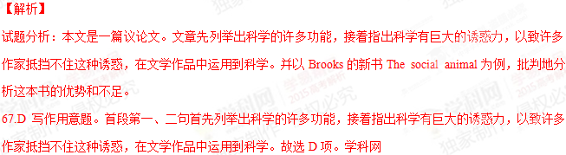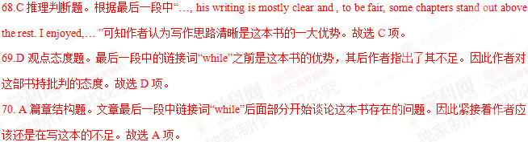【考点定位】议论文阅读
【名师点睛】议论说理类文章具有以下特点：1．一般按提出问题、分析问题、解决问题的方法写作。作者一般从日常生活中的热点问题、社会上的重大问题、与读者息息相关的问题入手，即提出问题。然后，分析利弊，举例说明，推理判断，即分析问题。最后，阐述观点，提出办法，即解决问题。2．以作者的观点或情感为核心，对细节推理等方面进行考查。3．文章的主题一般是生活中的热点问题、重大问题或与生活息息相关的问题等。考生应注意抓住作者提出的观点、给出的例证及最后得出的结论。同时，理清作为论据的诸多事例和理由之间以及它们和观点/结论之间的内在联系，把握文章的结构。
第四部分：书面表达（共两节，满分50分）
第一节：完成句子（共10小题；每小题2分，满分20分）
阅读下列各小题，根据汉语提示，用句末括号内的英语单词完成句子，并将答案写在答题卡上的相应题号后。
例：______ was that the young player performed extremely well in the table tennis
tournament. (delight)
令球迷欣喜的是那位年轻的球员在乒乓球锦标赛中表现得极为出色。
答案：What delighted the fans/made the fans delighted
71. .If she had been aware that the mushroom were poisonous, she ___them for dinner.(pick)
要是知道这些蘑菇有毒，她不会采来做晚餐了。
72.___the beef being cooked on the stove,the mother pictured the whole family having meals together.(look)
看着炉子上炖着的牛肉，妈妈想象着一家人在一起吃饭的画面。
73.The director,___a dorm-room in the Film Academy, has already make four films.(share)
这位导演已经执导了四部电影，在电影学院求学时杰克与他同住在一间寝室。
74.Into the complete silence of the waiting class____, “Good morning,children.”(come)
在全班同学静静的等待中传来了老师甜甜的嗓音：“孩子们，早上好”。
75.____will not make any difference to our arrangements.(say)
无论她说什么，都是不会对我们的安排有影响。
76.We must act as quickly as possible now. Just tell us ___the task or not.(undertake).
现在我们必须采取行动。你就告诉我们，你能否承担这项任务吧。
77.The professor was delighted to find that two thirds of the project ___by the students independently.(finish)
教授高兴地发现学生们已独立完成了该项目三分之二的工作。
78.____that they found the long lost sword of the Ming Dynasty .(be)
就是在这个湖里，他们发现了失踪已久的明代宝剑。
79._____to only a few people here,his reputation abroad is very great.(know).
虽然这里只有几个人知道他，但他在国外的名气却很大。、
80.Many bad habits can be especially difficult to cure because they are likely ___at a very young age.(from).
许多坏习惯特殊气味难以纠正，因为它们可能是人们在年幼时就形成了的。
【答案】
71.would not have picked
72.Looking atWhen/While (she was) looking at
73.with whom Jack shared/who shared with Jack
74.came the teacher’s sweet voice
75.Whatever she says
76.whether/if you can undertake
77.had (already) been finished
78. It was in this lake
79. Although/Though he is known
80.to have been formed
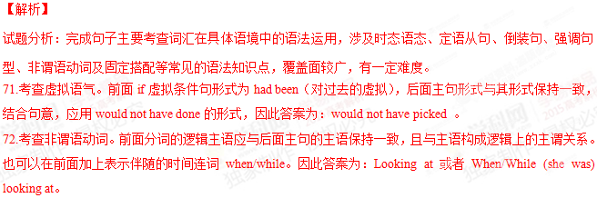
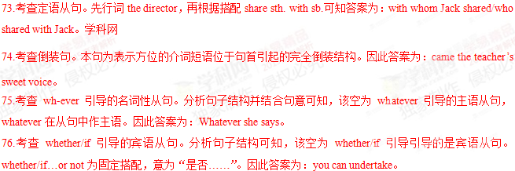
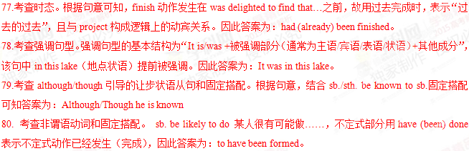【考点定位】考查单词在语境中的灵活运用。
【名师点睛】今年湖北高考英语完成句子部分考点分布均匀，总体难度不大，考生比较容易得分。非谓语动词仍然是考查重点，共两道题，72题考查非谓语动词作伴随状语，80题考查be likely to do；从句部分考查了四道题，是今年的热点，75题考查主语从句，76题考查的宾语从句，73考察定语从句，79题考查的although让步状语从句。时态题77题考查现在过去完成时态；虚拟语气71题考察if条件中的虚拟；74题考查的是完全倒装，这是第二年考查完全倒装，方位副词在句首的完全倒装，特征比较明显。
第二节目短文写作
请根据以下提示，并结合具体事例，有英语写一篇短文。
Questioning is a bridge to learning. When you begin to doubt something and search for an answer,you will learn.
注意：1.无须写标题；
2.除诗歌外，文体不限；
3.内容必须结合你生活中的具体事例；
4.文中不得透露个人姓名和学校名称；
5.词数不少于120，如引用提示语则不计入总词数。
____________________________________________________________________________________________________________________________________________________________________________________________________________________________________________________________________________________________________________________________________________________________________________________________________________________________________________________________________________
【参考答案】
Questioning can lead to searching for an answer. If we are in the habit of raising doubts as to whether what we are told is true, we can find the correct answer and learn more.
Two years ago, our teacher offered us an answer to a difficult math problem in class. Although the answer seemed a little strange, nobody but I doubted it. Thinking that his solution might be wrong, I carefully analyzed the problem and tried to work it out in a different way. Half an hour later, I managed to find the correct answer. When I showed my answer to him, the teacher praised me for my independent thinking.[来源:学,科,网]
From this experience I have learnt that questioning can serve as a bridge that helps us to seek the truth.
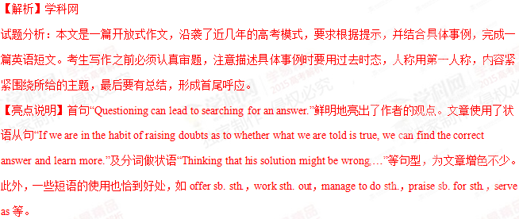【考点定位】考查开放式作文。
【名师点睛】今年的高考短文写作仍然沿袭了近几年的模式，考生对“提纲类开放式”作文比较熟悉。考生答题时，先提取关键词question，doubt，learn来确定中心，确保不走题。通过英文提示，考生很容易得出这一观点：质疑既是求知的一种方式，也是“批判性思维”的起点。这对引导考生进行独立思考，发展批判性思维，培养创新意识，极具启发和指导作用。

