2014年普通高等学校招生全国统一考试（陕西卷）
英语试题
第一部分：英语知识运用（共四节，满分55分）
- 语音知识（共5小题；每小题1分，满分5分）
从每小题的A、B、C、D四个选项中，找出其划线部分与所给单词的划线部分读音相同的选项，并在答题卡上将该选项涂黑。
1.open
A. become B. across C. lonely D. balcony
2. teacher
A. great B. heavy C. idea D. disease
3. physics
A. pleasure B. music C. sure D. increase
4. weather
A. warmth B. method C. theory D. breathe
5. brown
A. however B. sorrow C. knowledge D. owner
第二节 情景对话（共5小题；每小题1分，满分5分）
根据对话情境和内容，从对话后所给的选项中选出能填入每一空白处的最佳选项，并在答题卡上将该选项涂黑。选项中有两个为多余选项。
Linda: Hello, George. 6
George: Hi, Linda. I’m reading a tourist guide to Europe.
Linda: 7
George: Yes, i’m looking to such a trip. Hey, have you ever been there?
Linda: Yes. I’ve actually visited my countries in Europe; France, Germany, Italy and Austria, for example.
George: 8 And how long did you stay?
Linda: Two years ago. For over one month.
George: Did you like it?
Linda: 9 There are many ancient churches and castles. It’s the best trip I’ve ever taken.
George: Sounds great. 10
Linda: Good idea. You won’t regret it.
A: Of course.
B: Not exactly.
C: What are you doing?
D: When did you go there?
E: Do you plan to move to Europe?
F: Are you thinking of visiting Europe some day?
G: I decide to make a trip next October on my annual leave.
第三节 语法和词汇知识（共15小题；每小题1分，满分15分）
从每小题的A、B、C、D四个选项中，选出可以填入空白处的最佳选项，并在答题卡上将该选项涂黑。
11. — I got that job I wanted at the public library.
— ___________! That’s good news.
A. Go ahead B. Cheers C. Congratulations D. Come on
12. It’s quite hot today. Do you feel like _________ for a swim?
A. to go B. going C. go D. having gone
13. Please send us all the information _________ you have about the candidate for the position.
A. that B. which C. as D. what
14. The Scottish girl ________ blue eyes won the first prize in the Fifth Chinese Speech Contest.
A. by B. of C. in D. with
15. ________ the delayed flight will take off depends much on the weather.
A. Why B. When C. That D. What
16. — You know, I met my girlfriend’s parents for the first time only yesterday.
— ________? I thought you’d met them before.
A. So what B. Pardon C. Really D. What for
17. No sooner ________ stepped on the stage than the audience broke into thunderous applause.
A. had Mo Yan B. Mo Yan had C. has Mo Yan D. Mo Yan has
18. Ralph W. Emerson would always ______ new ideas that occurred to him.
A. set off B. set about C. set up D. set down
19. ________ village where I was born has grown into ________ town.
A. The; a B. A; the C. The; the D. A; a
20. ________ the difficult math problem, I have consulted Professor Russell several times.
A. Working out B. Worked out C. To work out D. Work out
21. I’d appreciate ________ if you could let me know in advance whether or not you will come.
A. it B. you C. one D. this
22. During his stay in Xi’an, Jerry tried almost all the local foods his friends ________,
A. would recommend B. had recommended
C. have recommended D. were recommending
23. We would rather our daughter ________ at home with us, but it is her choice, and she is not a child any longer.
A. would stay B. has stayed C. stayed D. stay
24. The young couple, who returned my lost wallet, left _______ I could ask for their names.
A. while B. before C. after D. since
25. My book, The House of Hales, is missing. Who ________ have taken it?
A. need B. must C. should D. could
第四节 完形填空（共20小题；每小题1.5分，满分30分）
阅读下面短文， 从短文后各题的A、B、C、D四个选项中，选出适合填入对应空白处的最佳选项，并在答题卡上将该选项涂黑。
It was Mother’s Day and I was shopping at the local supermarket with my five-year-old son, Tenyson. As we were 26 , we realized that only minutes earlier an 27 woman had fallen over at the entrance and hit her head on the ground. 28 was with her, but there was blood everywhere and the woman was embarrassed and clearly in shock. 29 a lot of people stopped to help out.
30 we were walking towards the scene, Tenyson became very 31 about what had happened to the elderly couple. He 32 to me, “Mom, it’s not much fun falling over in front of 33 .” Seeing that there was a flower stall（摊位）at the front of the supermarket, he added.,” Why shouldn’t we 34 the lady a flower? It will make her feel better.” I was 35 that he’d come up with this 36 idea. So we went over and told the flower seller 37 we wanted. “Just take it,” she replied. “I 38 take your money for such a wonderful 39 .”
By now medical staff had arrived, and were 40 the injured woman. We gave the flower to the woman’s husband and I told him it was 41 my son. At that, the old man started crying and said, “Thank you very much.” He then turned to me, “You have a 42 son. Happy Mother’s Day to you.”
The man bent down and gave his wife the flower, telling ger who it was from. 43 being badly hurt, the old lady looked up at Tenyson with 44 in her eyes and gave him a little 45 .
26. A. leaving B. driving C. moving D. stopping
27. A. injured B. awkward C. honest D. elderly
28. A. Her husband B. My son C. The crowd D. The seller
29. A. Specifically B. Particularly C. Interestingly D. Fortunately
30. A. If B. Since C. While D. Unless
31. A. guilty B. curious C. angry D. worried
32. A. complained B. said C. lied D. responded
33. A. no one B. someone C. everyone D. anyone
34. A. lend B. bring C. leave D. buy
35. A. amazed B. shocked C. puzzled D. concerned
36. A. wise B. sweet C. innocent D. crazy
37. A. which B. when C. what D. whether
38. A. must not B. can’t C. may not D. needn’t
39. A. scene B. habit C. flower D. deed
40. A. checking with B. looking after C. operating on D. paying for
41. A. from B. to C. with D. about
42. A. respectful B. cheerful C. successful D. wonderful
43. A. Out of B. Regardless of C. Thanks to D. As to
44. A. love B. hope C. pity D. pain
45. A. idea B. money C. smile D. comfort
第二部分：阅读理解（共两节，满分40分）
第一节：（共15小题；每小题2分，满分30）
阅读下列四篇短文，从每小题后所给的A、B、C、D四个选项中，选出最佳选项，并在答题卡上将该选项涂黑。
A
Our warming planet is expected to face serious water crisis（危机）in the coming decades — which means each nation’s natural resource will be more important than ever.
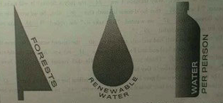

Percentage of total land area covered by forests（2011）
WORLD AVERAGE
30. 88
TOP 5 AVERAGE
90.15

Freshwater resource, cubic kilometers per person（2011）
WORLD AVERAGE
6,122
TOP 5 AVERAGE
244, 973
Freshwater resource, cubic kilometers per year（2011）
WORLD AVERAGE
241
TOP 5 AVERAGE
3.642

1. ICELAND
532,891
REST OF TOP 5
2. Guyana 304,723
3. Suriname 166,112
4. Papua New Guinea 114,216
5. Bhutan 106,923

102. CHINA
2,092
1. BRAZIL
5,418
REST OF TOP 5
2. Russian Federation 4,313
3. Canada 2,850
4. United States 2,818

5. CHINA
2,813
1. SURINAME
94.58
REST OF TOP 5
2. Micronesia 91.66
3. Seychelles 88.48
4. Samoa 88.40
5. Palau 87.61

123. CHINA
22.47

46. According to the statistics, what is the world average of freshwater resource per person?
A. 244,973 cubic kilometers B. 241 cubic kilometers
C. 3,642 cubic kilometers D. 6,122 cubic kilometers
47. Which country or region has the most freshwater resource per year?
A. Guyana B. Brazil C. Iceland D. China
48. Which country or region appears twice on the top 5 lists?
A. Bhutan B. Seychelles C. Canada D. Suriname
B
When I told my father that I was moving to Des Moines, Iowa, he told me about the only time he had been there. It was in the 1930s, when he was an editor if the literary magazine of Southern Methodist University（SMU）in Dallas, Texas. He also worked as a professor at SMU, and there was a girl student in his class who suffered from a serious back disease. She couldn;t afford the operation because her family was poor.
Her mother ran a boardinghouse in Galveston, a seaside town near Houston, Texas. She was cleaning out the attic（阁楼）one day when she came across an old dusty manuscript（手稿）. On its top page were the words, “By O. Henry”. It was a nice story, and she sent it to her daughter at SMU, who showed it to my father. My father had never read the story before, but it sounded like O. Henry, and he knew that O. Henry had once lived in Houston. So it was possible that the famous author had gone to the beach and stayed in the Gainestown boardinghouse, and had written the story there and left the manuscript behind by accident. My father visited an O. Henry expert at Columbia University in New York, who authenticated the story as O. Henry’s.
My father then set out to sell it. Eventfully, he foud himself in Des Moines, meeting with Gardner Cowles, a top editor at the Des Moines Register. Cowles loves the story and bought it on the spot. My father took the money to the girl. It was just enough for her to have the operation she so desperately needed.
My father never told me what the O. Henry story was about. But i doubt that it could have been better than his own story.
49. Who found the O. Henry’s manuscript?
A. The girl’s mother. B. The author’s father.
C. The girl. D. The author.
50. Which of the following might explain the fact that the manuscript was found in the attic?
A. O. Henry once worked in Houston. B. O. Henry once stayed in Galveston.
C. O. Henry once moved to Des Moines. D. O. Henry once taught at SMU.
51. The underlined word “authenticated” in Paragraph 2 probably means __________.
A.named B.treated C.proved D.described
52. According to the text, why did the author’s father go to Des Moines?
A. To sell the O. Henry story. B. To meet the author himself.
C. To talk with the O. Henry expert. D. To give money to the girl.
C
Why do Americans struggle with watching their weight, while the French, who consume rich food, continue to stay thin? Now a research by Cornell University suggests how life style and decisions about eating may affect weight. Researchers concluded that the French tend to stop eating when they feel full. However, Americans tend to stop when their plate is empty or their favorite TV show is over.
According to Dr. Joseph Mercola, a health expert, the French see eating as an important part of their life style. They enjoy food and therefore spend a fairly long time at the table, while Americans see eating as something to be squeezed between the other daily activities. Mercola believes Americans lose the ability to sense when they are actually full. So they keep eating long after the French would have stopped. In addition, he points out that Americans drive to huge supermarkets to buy canned and frozen foods for the week. The French, instead, tend to shop daily, walking to small shops and farmers’ markets where they have a choice of fresh fruits, vegetables, and eggs as well as high-quality meats for each meal.
After a visit to the United States, Mireille Guiliano, author of French Women Don’t Get Fat, decided to write about the importance of knowing when to stop rather than suggesting how to avoid food. Todays she continues to stay slim and rarely goes to the gym.
In spite of all these differences, evidence shows that recent life style changes may be affecting French eating habits. Today the rate of obesity — or extreme overweight — among adults is only 6%. However, as American fast food gains acceptance and the young reject older traditions, the obesity rate among French children has reached 17% — and is growing.
53. In what way are the French different from Americans according to Dr. Joseph Mercola?
A. They go shopping at supermarkets more frequently.
B. They squeeze eating between the other daily activities.
C. They regard eating as a key part of their lifestyles.
D. They usually eat too much canned and frozen food.
54. This text is mainly the relationship between _________.
A. Americans and the French B.life style and obesity
C.children and adults D.fast food and overweight
55. The text is mainly developed __________.
A.by contrast B.by space C.by process D.by classification
56. Where does this text probably come from?
A. A TV interview B. A food advertisement C. A health report D. A book review
D
One afternoon last week, I saw three tearful children from my son’s school being comforted by teachers. That morning, my 11-year-old had stomach pains, retching（干呕）into a bowl. Talking to other mothers later, I heard about other children with stomachache or difficult sleeping the night before.
What caused so much pain? Sports day. Sports day might be necessary at a highly-competitive independent school, but not at a village primary school. For the children who can fly like the wind, sports day cause no problem. For those who are overweight or just not good at sport, it is nightmare（噩梦）. Even for those who enjoy running but fall halfway down the track in front of the entire school and their parents, it can prove a disease.
Why do we put our children through this annual suffering? Some may say competition is character building; or it’s taking part, not winning, that’s important; or that’s a tradition of school life. I just felt great pity for those children in tears or in pain.
Team games at the end of sports day produced some close races, wild enthusiasm, lots of shouting — and were fun to watch. More importantly, the children who were not so fast or quick at passing the ball were hidden a little from everyone’s eyes. Some of them also had the thrill of being on the winning side.
I wish that sports day could be abandoned and replaced with some other less competitive event. Perhaps an afternoon of team games, with a few races for those who want them, would be less stressful for the children and a lot more fun to watch.
57. What can we learn about the author’s son from Paragraph 1?
A. He talked with some mothers. B. He comforted his classmates.
C. He had difficulty in sleeping. D. He suffered from stomachache.
58. Sports day is still an annul event in this school probably because __________.
A.this is an independent school B.it is a tradition of the school
C.it helps children lose weight D.children enjoy watching sports
59. What does the author think about team games?
A. They should include more stressful races. B. They are acceptable to different children.
C. They should be abandoned at primary school. D. They are less fun for those who love running.
60. What is the author’s attitude towards sports day?
A. Critical. B. Neutral. C. Positive. D. Ambiguous.
第二节 （共5小题；每小题2分，满分10分）
根据短文内容，从下框的A~F选项中选出能概括每一段主题的最佳选项，并在答题卡上将该选项涂黑。选项中有一项为多余项。
A. Real winners of tourism
B. Negative effects of tourism
C. Growing tourism in the world
D. Developing tourism with caution
E. Benefits to the locals from tourism
F. Tourism problems and possible solutions
61. __________________
On the Mediterranean island of Majorca in Spain, the locals are angry. Too late. In the last quarter of 20th century, they obtained profit from foreign visitors wanting to buy up property on their beautiful island. Suddenly, it occurred to Majorca that the island no longer belonged to them. Its 630,000 inhabitants（居民）are increasingly convinced that the 14 million visitors a year are far too much of a good thing. Water is in short supply, pollution is worsening, and there is no affordable housing left for them to buy.
62. __________________
Tourism is the world’s largest and fastest growing industry. In 1950, 25 million people traveled abroad; last year, it was 750 million. The World Tourism Organization predicts that 1.6 billion people, by 2020, will travel each year, spending over two trillion（万亿）US dollars.
63. __________________
The host country may not see many benefits. In Thailand, 60% of the $ 4 billion annual tourism income leaves the country. Tourists arrange by travel companies tend to stay at a big foreign-owned hotels, buying few local products. Mass tourism（团队旅游）usually leaves little money inside the country and most of the money goes to the airlines, the tour operators,and the foreign hotel owners, who are the final winners of tourism.
64. __________________
These days the industry’s most urgent question may be how to control the flow of tourist. A typical example of this is Italy, where great cultural centers like the Florence and Venice can’t handle all the tourists they get every summer. In Florence, it’s half inhabitants have to live with the pollution, traffic jam, and crime caused by 11 million visitors a year. Now there is talk about how to solve these problems, like raising hotel taxes, or even changing admission to some public squares. The idea is to discourage at least some visitors, as well as to pay for cleaning up the mess.
65. __________________
For many poorer countries, tourism may still offer the best hope foe development. The Vietnamese are doing their best to open up their country. Libya has paid $ 1 million for a study. They all wanted tourists. Yet if something isn’t done, tourism seems certain to become the victim of its success. Its effect on the environment is a major concern. For this reason, tourist organizations need to have second thoughts about what exactly they are trying to sell.
第三部分 写作（共三节，满分55分）
- 单词拼写（共10题；每题1分，满分10分）
根据下列各句句意和空白之后的汉语提示词，在答题卡指定区域的横线上写出对应单词的正确、完整形式，每空只写一词。
66. The first few weeks of this __________________（春天）were unusually cold.
67. Take the lift to the __________________（第十）floor, and you will find the gym.
68. We can eat out if you like, but I would __________________（更喜欢）to stay in.
69. Keep in mind that it is a shame to __________________（浪费）food.
70. It was __________________（勇敢的）of Mary to quit her job and start her own business.
71. I’m happy that my 80-year-old grandma has learned how to __________________（下载）from the Internet.
72. They failed to reach a settlement, because they __________________（不同意）too much with each other.
73. Men and Women must be treated __________________（平等地）in education and employment.
74. On June 27, 2012, the Jiaolong reached a __________________（深度）of 7, 062 meters in the Pacific Ocean.
75. The advertisement for engineers in the local paper attracted many __________________（申请人）.
第二节 短文改错（共10小题；每小题1.5分，满分15分）
假定英语课上老师要求同桌之间交换修改作文，请你修改你同桌系的以下作文。文中共有10处语言错误，每句中最多有两处。错误涉及一个单词的增加、删除或修改。
增加：在缺词处加一个漏词符号（∧），并在其下面写出该加的词。
删除：把多余的词用斜线（ ）划掉。
修改：在错的词下划一横线（ ），并在该词下面写出修改后的词。
注意：1.每处错误及修改均仅限一词；
2.只允许修改10处，多者（从第11处起）不计分。
My father took me out camping for the first time when I was seven. He wanted teach me about animals, insects and trees. My uncles all come along with bows and arrows for hunting.
One evening at sunset, we sat by the fire, have our barbecue. Just then a bird was flying over us. My uncles immediate jumped up and shot their arrows on the bird. Neither of the arrows hit the target. Suddenly the arrows was flying down at us from the sky — they were looked like rain! We ran to escape but fortunately no one was injured.
That day I didn’t learn much about animals, insects or trees, but I learnt a impressive lesson about gravity!
第三节 书面表达（满分30分）
假定你是中学生李华。美国一个中学校长代表团即将访问你校并出席英语周的一项活动。请根据写作要点和写作要求写一篇欢迎词。
写作要点：
1.表示对客人的欢迎；
2.介绍此项活动（如活动目的、内容等）；
3.表达对客人的祝愿。
写作要求：
1.词数不少于100；
2.称呼已经给出，请写欢迎词正文；
3.不能使用真实姓名和学校名称。
Dear American guests,
____________________________________________________________________________________
__________________________________________________________________________________________

2014年陕西卷英语试题参考答案
一、语音知识
1-5: CDBDA
二、情景对话
6-10: CFDAG
三、语法和词汇知识
11-15: CBADB 16-20: CADAC 21-25: ABCBD
四、完形填空
26-30: ADADC 31-35:DBCDA 36-40: BCBDB 41-45: ADBAC
五、阅读理解
46-48: DBD 49-52: ABCA 53-56: CBAC 57-60: DBBA
六、信息匹配题（六选五）
61-65: BCAFD
七、单词拼写
66.spring | 67.tenth | 68.prefer | 69.waste | 70.brave
71.download | 72.disagreed | 73.equally | 74.depth | 75.applicants
八、短文改错
My father took me out camping for the first time when I was seven. He wanted ∧ teach me about animals,
to
insects and trees. My uncles all come along with bows and arrows for hunting.
came
One evening at sunset, we sat by the fire, have our barbecue. Just then a bird was flying over us. My uncles
having
immediate jumped up and shot their arrows on the bird. Neither of the arrows hit the target. Suddenly the arrows was
immediately at none were
flying down at us from the sky — they were looked like rain! We ran to escape but fortunately no one was injured.
删除were或looked and
That day I didn’t learn much about animals, insects or trees, but I learnt a impressive lesson about gravity!
an
九、书面表达
Dear American Guest,
On behalf of our school, I would like to express our warm welcome to you. We are lucky to have you here in the middle of our English Week Activities.
As scheduled, we have English Talent Show today. The purpose of this program is to develop our interest in English learning and practical abilities in listening and speaking. The programme consists of the following activities: recitation, singing, word spelling, story telling and so on. The Show will begin at two o’clock this afternoon at the Student Centre. Dear guests, you are welcome to take part in some activities. I hope we students will benefit from your presence.
I sincerely wish you a pleasant time with us. Thank you.

第一部分
第一节
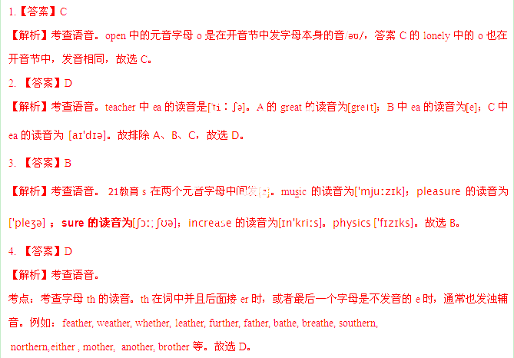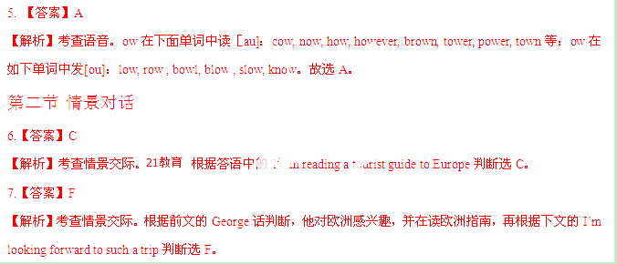8.【答案】D
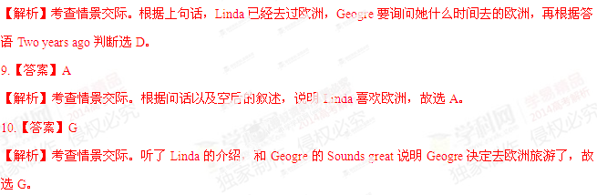第三节
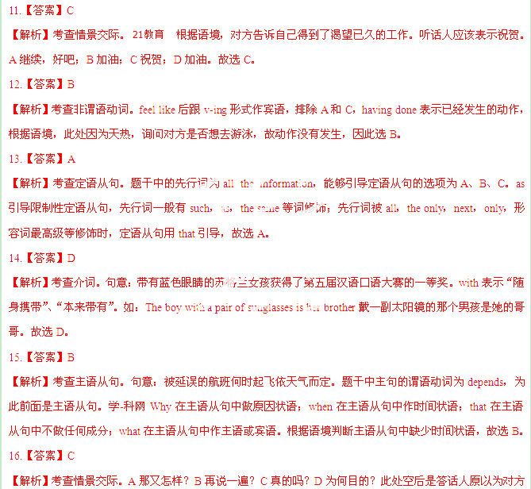已经见到女朋友的父母，所以表现出特别吃惊。故选C。
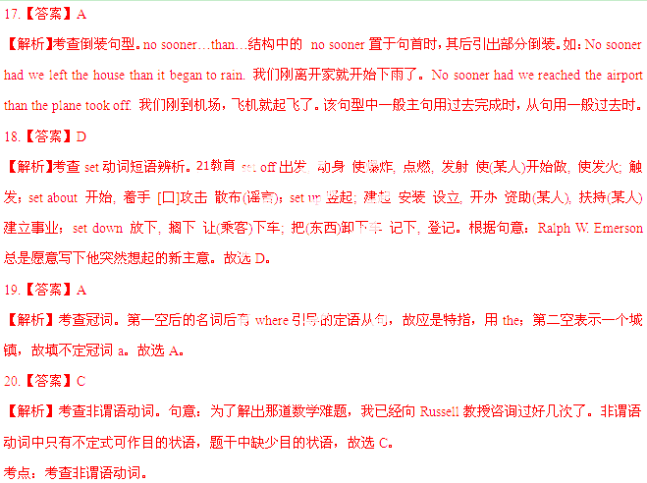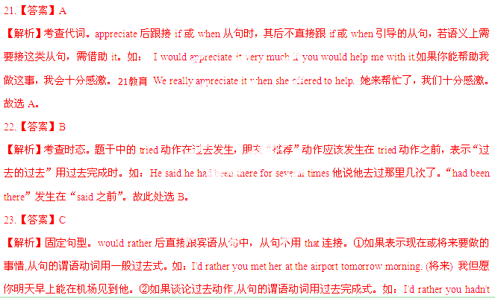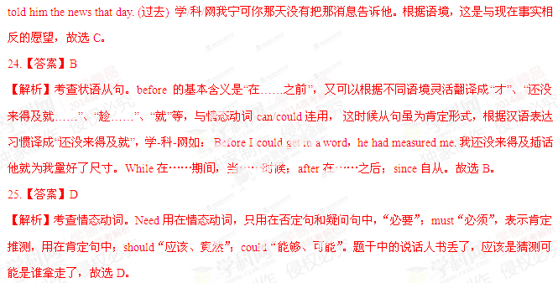第四节 完形填空
【答案】
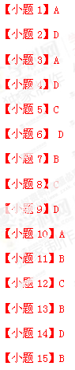
【小题16】A
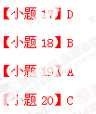
【解析】
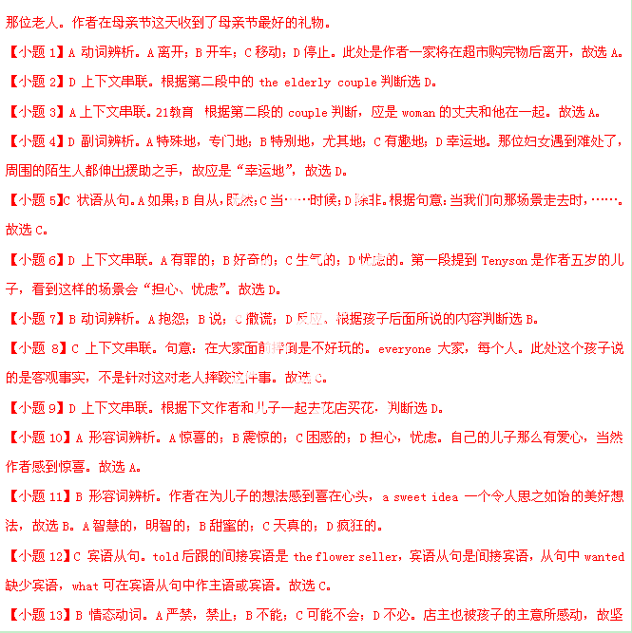持不能收钱。所以选B。21世纪教育网
【小题14】D上下文串联。A场景；B习惯；C花； D好事。这应该是店主也认为这是件好事，故选D。
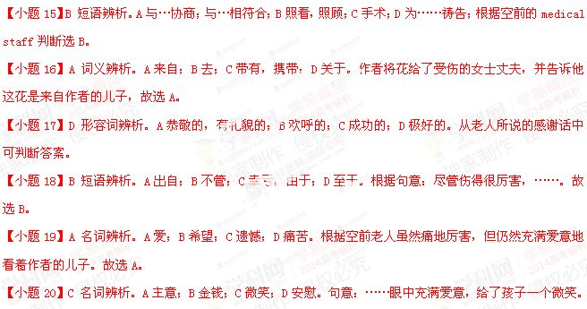第二部分
第一节
A
【答案】

【解析】
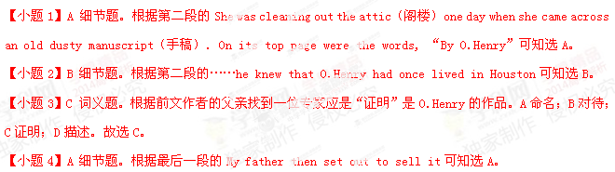 C
【答案】
 D
【答案】
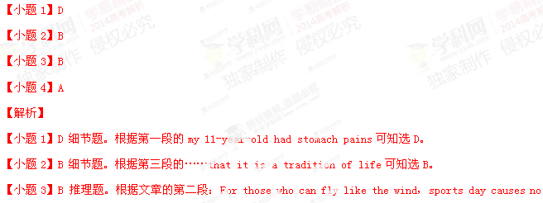problem…，it can be a disaster可知选B。
第二节
【答案】
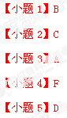
【解析】
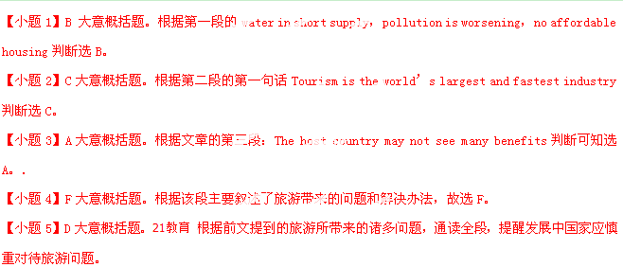第三部分：写作
第一节单词拼写21世纪教育网
【答案】


【解析】
试题分析：
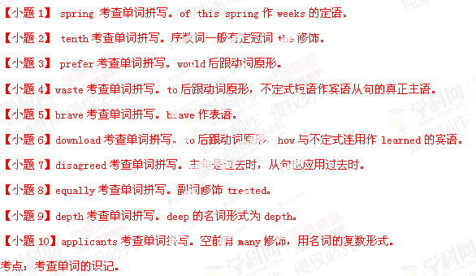
第二节短文改错：
【答案】
[来源:21世纪教育网]
【小题10】a→an21世纪教育网
【解析】21世纪教育网
试题分析：
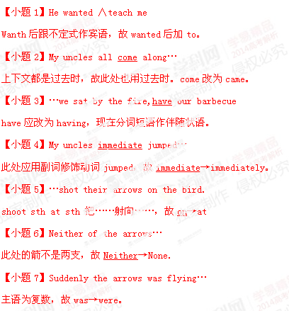
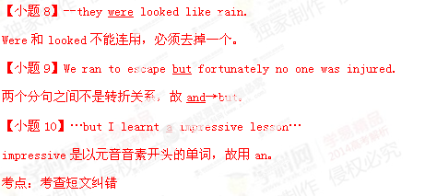
第三节 书面表达
【解析】
